**Similes and Metaphors Name:________________________**

SoW Tab

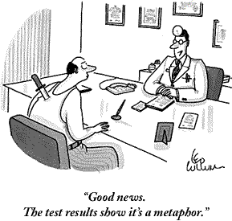

**Similes:** compare **X** to **Y** using words such as “like” or “as” (sometimes “than”)

(ie: “My love is like a red, red rose.

OR

“He was as cold as ice.”)

**Metaphors:** compare **X** to **Y** *without* using “like” or “as’(They often use “is” or “are” to compare to things directly)

(ie: “Her eyes are homes of silent prayer,”

“My bedroom is a pigsty.”)

**Read the following comparisons, and write in the margin next to the phrase whether or not this is an example of a simile (S) or a metaphor (M).**

____It hurt like your tongue hurts after you accidentally staple it to the wall.

____Computers are the vehicles of tomorrow.

____McBride fell 12 stories, hitting the pavement like a Hefty bag filled with vegetable soup.

____The parks are the lungs of London. (William Pitt)

____He spoke with the wisdom that can only come from experience, like a guy who went blind because he looked at a solar eclipse without one of those boxes with a pinhole in it and now goes around the country speaking at high schools about the dangers of looking at a solar eclipse without one of those boxes with a pinhole in it.

____Her vocabulary was as bad as, like, whatever.

____Home is the girl's prison and the woman's workhouse

____The politician was gone but unnoticed, like the period after the Dr. on a Dr. Pepper can.

____My heart is a lonely hunter that hunts on a lonely hill. (Fiona McLeod)

____His thoughts tumbled in his head, making and breaking alliances like underpants in a dryer without Cling Free. ☺

____Even in his last years, Grandpappy’s mind was a steel trap, only one that had been left out so long, it had rusted shut.

____Her hair glistened in the rain like nose hair after a sneeze.

____The hailstones leaped from the pavement, just like maggots when you fry them in hot grease.

**Personification:** giving human qualities to non-human things. Yes or no—is this an example of personification:  
_____ The snow was a monster, wiping out everything in its path.  
_____ The trees waved gently; their branches were like long arms reaching out to the departing girl.  
_____ The copy machine hates me.  
_____ The fog comes in on little cat feet.

**Question**: Can something be an example of more than one type of figurative language?

What does figurative language do?