Lyric Poems
-are rhyming poems
-are “song-like” in that they could be put to music
-are focused on strong emotions like: _____________________________________________________________
________________________________________________________________________________________________________.
-to emphasize an emotion, authors often use sound devices and figurative language (similes, metaphors, personification, alliteration, etc.) to develop the tone.

Read the following poem, and think about:
- the emotion/tone
- the sound devices, figurative language, imagery, or other craft choices the author uses to develop this tone.

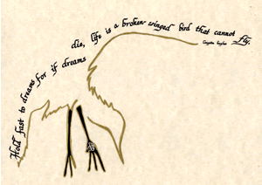
“Dreams” by Langston Hughes
Hold fast to dreams
For if dreams die
Life is a broken-winged bird
That cannot fly

Hold fast to dreams
For when dreams go
Life is a barren field
Frozen with snow.
What is this poem about?

What is the tone?

Highlight and label the craft choices the author uses. How does this emphasize the tone?

