Imagery
Imagery helps your reader see, feel, taste, smell, and touch your poem—it paints a picture in your reader’s mind.

In the poem below, highlight and label the places where the author uses an example of imagery.

“Preludes” by T.S. Eliot

Smell

The winter evening settles down
With smell of steaks in passageways.
Six o'clock.
The burnt-out ends of smoky days.
And now a gusty shower wraps
The grimy scraps
Of withered leaves about your feet
And newspapers from vacant lots;
The showers beat
On broken blinds and chimney-pots,
And at the corner of the street
A lonely cab-horse steams and stamps.
And then the lighting of the lamps.

Abandoned Farmhouse
by Ted Kooser
He was a big man, says the size of his shoes
on a pile of broken dishes by the house;
a tall man too, says the length of the bed
in an upstairs room; and a good, God-fearing man,
says the Bible with a broken back
on the floor below the window, dusty with sun;
but not a man for farming, say the fields
cluttered with boulders and the leaky barn.
A woman lived with him, says the bedroom wall
papered with lilacs and the kitchen shelves
covered with oilcloth, and they had a child,
says the sandbox made from a tractor tire.
Money was scarce, say the jars of plum preserves
and canned tomatoes sealed in the cellar hole.
And the winters cold, say the rags in the window frames.
It was lonely here, says the narrow country road.
Something went wrong, says the empty house
in the weed-choked yard. Stones in the fields
say he was not a farmer; the still-sealed jars
in the cellar say she left in a nervous haste.
And the child? Its toys are strewn in the yard
like branches after a storm—a rubber cow,
a rusty tractor with a broken plow,
a doll in overalls. Something went wrong, they say.
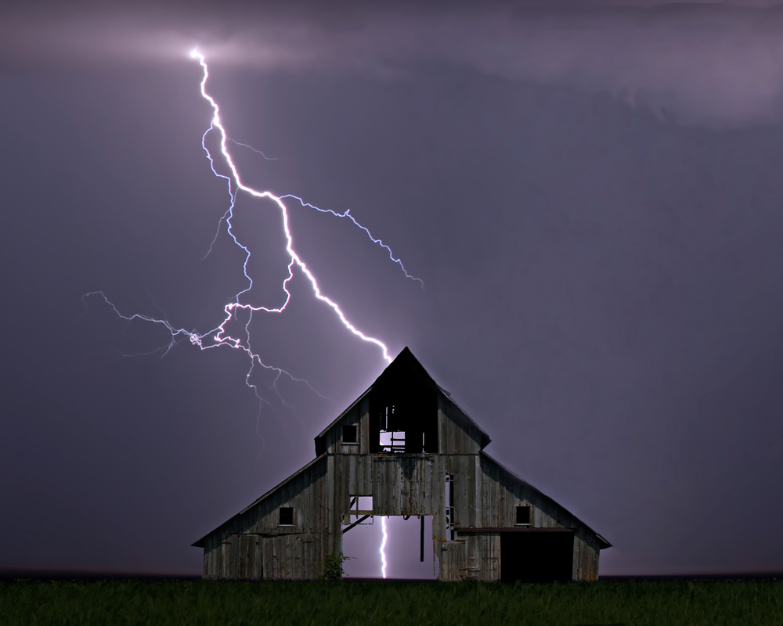
Read the two poems below that describe the picture above. One poem emulates T.S. Eliot’s “Preludes” and the other simply uses imagery. Use one of the pictures on the PowerPoint to try either type of poem .
The smell a of storm hangs in the air.
Cool breezes blow,
Ushering in the roll of
Dark purple clouds, heavy with
Impatient rain.
Thunder grumbles in the distance
And now the breezes are chased away by gusty winds
Rain pelts the pelts the ground, slanted sideways.
The lightning cracks, stabbing the earth
With brilliant prongs.
And thunder roars in approval
As chaos reigns in the sky.
The dusky purple clouds roll forward
With the scent of rain in the breezes.
Evening falls.
The cool breezes usher in the storm.
And now the thunder grumbles,
the low growl
of impatient anger waiting in the distance
and expectation.
The lightning cracks nearby
in brilliant prongs and stabs the earth,
and thunder roars in approval.
The grasses whip and sway
And then the chaos of the night.

